ECON 100 NOTES BY ZACK OGOMA

Economics is a science that studies human behavior as a relationship between ends and scares means which have alternative use.

Economics is divided into 2 groups ie

1.Macroeconomics

2.Microeconomics

-microeconomics-examines ecomomic behavior between individual economic agents.

-macroeconomics-adresses issues as unemployment,inflation ,monetary,fiscal policy within the entire economy ie it is concerned with aggregate of economics agents.

THE SCHOOLS OF THOUGHT

1.classical economics

2.neo classical economics

2.keynesian economics

1.CLASSICAL ECONOMICS

-considered to have begun after publication of –an inquiry into the nature wealth of nations by adam smith in late 16th centuary.

-smith identified land,labour and capital as 3 factors of production.

-he argued that the competitive markets tend to advance the economic intrest of the wider society even thogh their motives were narrow self intrest.

-other classical economists include Thomas Malthus(theory of population and food production)and david ricardo(theory of comparative advantage)

2.NEO CLASSICAL ECONOMICS

-ALSO called marginalism

-systemized supply and demand as joint determinant of price and quality in market equilibrium.

-these economists represent incentives and costs as playing a fundermental role in shaping econonomics agents in shaping decision making

Supply curve

Equilibrium

Demand curve

**PRICE**

**QUANTITY**

3.KEYNESIAN ECONOMICS

-brainchild of 20th centuary influential economist john maynerd Keynes

-in his book –the general theory of employment intrest and money he focused on the determinant of national income in short terms when

* He developed the Aggregate Demand-Aggregate Supply Framework(AD-AS).
  + - * AD=C+I+G+X-M
      * AS=C+S+T+X-M

-he also explains why high labour market unemployment might not be self correcting due to low effective demand.cause of great depression

POSITIVE ECONOMICS

-Attempts to understand economic behavior and the operation of the economic system without ascribing the value judgement

-it asks what is question

-describes what exists and how it works

* Examples of Positivistic Questions:
* Do MPs pay taxes?
* What determines the wage rate for unskilled workers?
* What would happen if income tax was abolished.

NOMATIVE ECONOMICS

-Look at the outcome of economic behavior and ask if the outcomes are good or bad and whether they can bettered ie it asks what ought to be question

-also called policy economics

-involves attaching value judgement and prescription for a course of action.

* Examples of Normative questions:
* Should government subsidize or regulate the cost of higher education?
* Should medical benefits for the elderly only be available to those in incomes below a certain threshold?
* Should MPs pay taxes?

-involves asking positivistic question,,the question if mps should pay taxes nessesarily involves economists taking positivic question concerning the benefits and costs of undertaking such decisions.

CENTRAL ECONOMIC PROBLEM

-questions that face economic systems are

1.what get produced?

2.who produces it?

3.who gets it?

-scaricity results when human wants are unlimited while resources are finite limited

-scarse resources leads to trade off between 2 or more competing resources use

-the coscept of opportunity cost is diaggramatically described PRODUCTION POSSIBILITY FRONTIERS(PPF)

-PPF is a graph showing all combinations goods and services that can be produced at a fixed amount of resources and existing technology.

-opportunity cost is the next best alternative forgone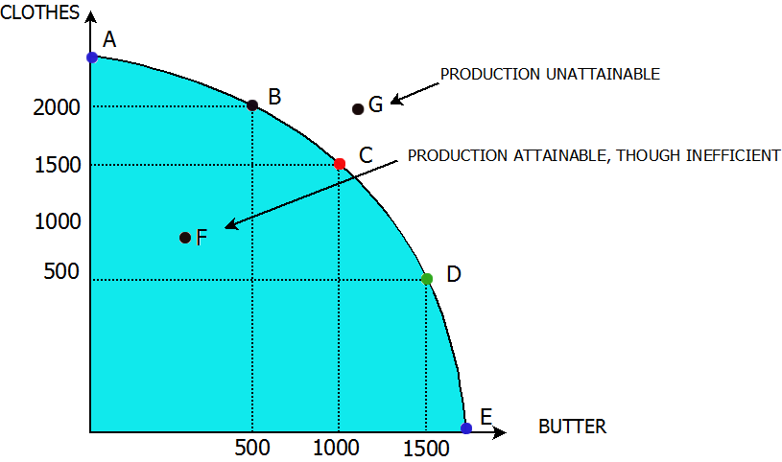

* Point A: implies that the economy is using all its resources to produce only clothes.
* Point E: implies that the economy is using all its resources, to produce only butter.
* Point B, C and D: the economy is using its resources to produce different combinations of clothes and butter.
* Point B: more clothes than butter are being produced while at D more butter than clothes are produced.

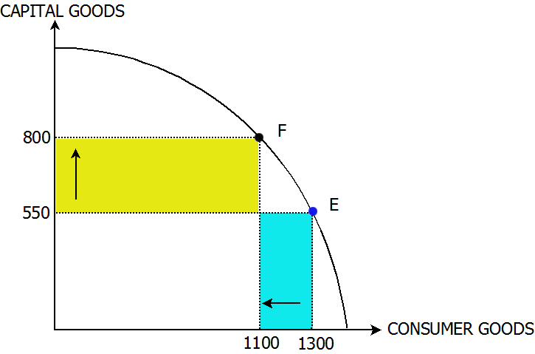

* Imagine an economy producing both capital and consumer goods. Its PPF would be as above.
* in moving from point E to F on the PPF about production of capital goods increases from 550 to 800 units. At the same time, the production of consumer goods decrease from 1300 to 1100 units.
* It can therefore be concluded that the opportunity cost of increasing the units of capital goods from 550 to 800 units is the 200units of consumer goods foregone. (i.e. 1300-1100)
* The slope of the PPF denotes the ratio of change in capital to the change in consumer goods. It is always negative and is known as the **Marginal Rate Of Transformation**.

ELEMENTS OF ECONOMIC ELEMENTS

-MARKET-the instution or arena where goods and services are exchanged

-firms and households interact in 2 basic types of market

1.product /output market

2.factor/ input market

-PRODUCT/OUTPUT MARKET.-goods and services intended for use in the household are exchanged in this market-firms supply ,household demand.

-in circular flow of income diagram ,the flow of economic activity is reflected by direction through which goods and services flow

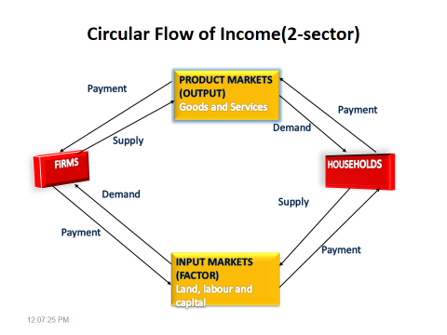

* Injections-e.g borrowings(loans), accumulated wealth.
* Leakages-e.g. savings
* When leakages>injections, recession results.
* When leakages<injections, boom(economic prosperity) results.
* **Factor/Input market** – households’ supply resources e.g. labour to firms that demand the same. In turn, firms pay workers for their time and skills.
* To produce goods and services, firms buy resources in factor markets. These resources are supplied by households.

Households may also loan their accumulated saving to firms of interest or exchange those savings for dividends